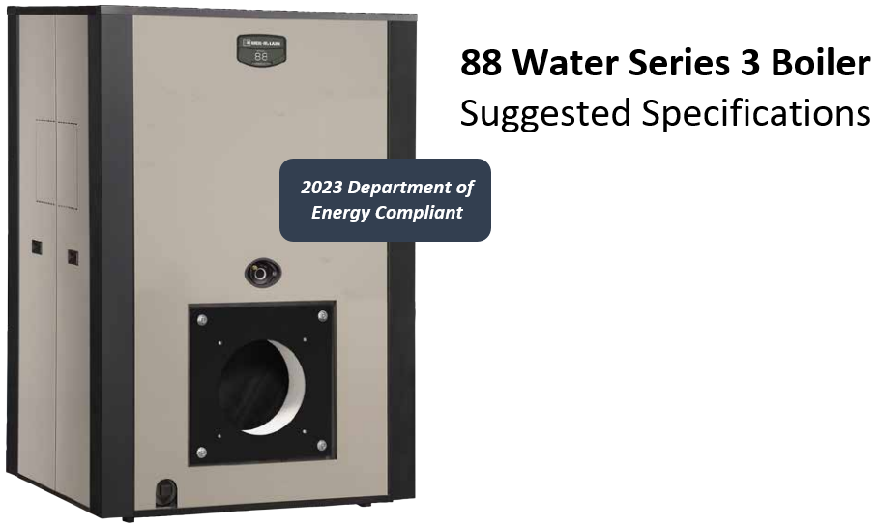

General Requirements

- Furnish and install ( ) low pressure, wet base, cast iron sectional boiler(s) with power burner(s) that pressurize the firebox and operate under forced and balanced draft. Boiler operation to be minimum of 84.0% gas thermal efficiency and 87.0% oil thermal efficiency.

Assemble and install boiler-burner unit(s) in compliance with manufacturer’s installation instructions.
- Weil-McLain (P)(A)(B) L, (P)(A)(B) G, (P)(A)(B) GL- ( ) 88-(W) (S)F boiler(s) with burner(s) capable of ( )” W.C. natural gas inlet pressure and/or No. 2 fuel oil.
- (B) Boiler-burner unit Field assembled (standard).
- (A) Boiler-burner unit with factory assembled sections.
- (P) Boiler-burner unit completely packaged and fire tested
- Natural or LP gas fired and/or No. 2 fuel oil.
- Water boiler.
- Forced or balanced draft.

Boiler(s) shall have an AHRI gross output(s) at 100% firing rate of ( ) MBH per boiler.

Boiler(s) shall be manufactured to conform to Section IV of the ASME Boiler and Pressure Vessel Code.
- Individual sections (and section assembly) to be hydrostatically pressure tested at factory in accordance with ASME requirements.
- Maximum 80 PSIG allowable working pressure as part of section with ASME symbol.

Regulatory Requirements
- Boiler(s) and controls to comply with applicable regulations.
- Provide U.L. labeled boiler(s) and burner(s).
- Provide add option for local code(s) ie: MASS Code, BAR

Submittals
- Submit shop drawings and product data.
- Submittal packet to include boiler (and burner) manufacturer descriptive literature, installation instructions, operating instructions, and maintenance instructions.

Product

Acceptable boiler/burner manufacturer(s) include(s):
- Weil-McLain only, as specified in Part 1, Paragraph C.
- Other manufacturer(s) or other Weil-McLain boiler(s) must comply with specifying engineer’s requirements, including:

Full intent of these specifications, and provide complete submittal including literature, wiring diagrams, fuel piping diagrams, and a list of similar installations.

Submittal to be presented to specifying engineer at least seven working days for approval before bid opening. Substitutions are not permitted after contract is awarded.

Burner(s) and Energy Management Control System(s) must be tested and approved for installation with specified boiler-by-boiler manufacturer.

Boiler construction
- Boiler sections
- Assembled with short, individual draw rods.
- Cast with sealing grooves for high temperature silicone-coated sealing rope to ensure permanent gas-tight seal.
- Sealed watertight by elastomer sealing rings, not cast iron nipples. Each port opening is machined to completely capture sealing ring between sections.
- Must be hydro-wall design to provide completely water-cooled combustion chamber.
- Provided with sufficient tappings to install required controls.
- Limited 10-year warranty against workmanship and defects to be in writing by manufacturer.

- Boiler(s)
- Provided with HXT bars to maximize heat transfer
- Provided with cast-in air elimination to separate air from circulating water.
- Provided with expansion tank tapping to divert separated air to expansion tank.
- Constructed to provide balanced water flow through entire section assembly using single supply and return connections for water. External headers are not required.
- Designed with a low silhouette to provide maximum headroom.
- Furnished with insulated burner mounting plate having necessary holes and tappings to mount burner. High temperature silicone-coated sealing rope is used to provide permanent gas-tight seal between front section and plate.
- Furnished with two observation ports (one in front and one in back) to allow visual inspection of the flame.
- Provided with cast iron flue collar with a built-in adjustable damper capable of being locked into place after adjustment.
- High temperature silicone-coated sealing rope used to provide permanent gas-tight seal between hood and section assembly.
- Furnished with heavy gauge steel cleanout plates to cover cleanout openings on the side of the boiler(s).
- Port openings must be of captured seal design – a machined groove assures uniform compression of the sealing ring and protects the seal from contaminants. Elastomer sealing rings are to be used to provide permanent watertight seal between sections. Unlike cast iron or steel push nipples, the elasticity of the seals fills any gaps caused by misalignment or expansion or contraction.
- Shipped with insulated heavy gauge steel jacket(s) with durable powdered paint enamel finish. Jacket designed to be installed after connecting supply and return piping. Side panels can be removed without tools for easy servicing.

Tankless heaters or indirect water heaters
- Provide ( ) internal tankless water heater(s) inserted into the left hand side of the tankless intermediate (TI) section in the opening provided. Allow 34” minimum clearance on left side of boiler for cleaning and servicing. Tankless openings must be on same side as the flue passage cleanout plates to minimize space requirements.

- Boiler foundation(s)
- Installer to construct needed support and level concrete foundation(s) where boiler room floor is uneven or will not support the weight of the boiler(s).

Boiler trim:
- All electrical components to be of high quality and bear the U.L. label.
- Water boiler(s) controls furnished:
- Combination low temperature limit (operating) and manual reset high temperature limit control.
- Low temperature limit set according to system design. High temperature limit set at least 20°F higher than the low limit (240°F is the maximum allowable water temperature).
- Combination pressure-temperature gauge with dial clearly marked and easy to read.
- ASME certified pressure relief valve, set to relieve at 30 PSIG. Optional relief valves available up to and including maximum allowable pressure. Side outlet discharge type; contractor to pipe outlet to floor drain or near floor, avoiding any area where freezing could occur.

- Low water cut-off:
- Boiler(s) to be furnished with U.L. labeled low water cut-off with ASME working pressure rating equal to the ASME rating of the relief valve.
- Do not use quick-connect fittings on boiler(s).
- Install cut-off according to manufacturer’s instructions.
- Locate so burner shuts down if boiler water level falls below allowable safe waterline

- Burner(s) construction, features and requirements:
- Burner fuel supply system and burner installation to conform to burner manufacturer’s installation instructions and applicable codes.
- Burner motor characteristics:  120/60/1,  240/60/1,  208/60/3,  240/60/3,  480/60/3.
- Control characteristics 120/60/1.
- Burner fuel – natural gas (4.0” W.C. minimum), No. 2 fuel oil.
- Code(s) -  standard boiler,  CSD-1,  FM,
- Burner(s) to have U.L. label(s) supplied by the burner manufacturer.
- Burner(s) designed to ensure high efficiency and good performance under forced draft conditions with 0.1” W.C. positive pressure at the flue collar.
- Burner to be adjusted to provide 9.5 to 10.0% CO₂ for gas and/or 11.5 to 12% CO₂ with zero smoke for oil firing.
- Burner(s) manufactured by:
❒ Power-Flame,  Riello,  Webster,  Beckett
- Burner operating mode:  on-off,  low-high-off,  low-high-low,  modulating

- Panel options – power on/fuel on light is standard on all burner(s) with panels.
- Call For Heat
- Ignition On
- Pilot Failure
- Low Water
- Flame Failure
- Silencing Switch
- Control Fuse and Holder
- Post Purge Timer
- Alarm Bell

